Guests

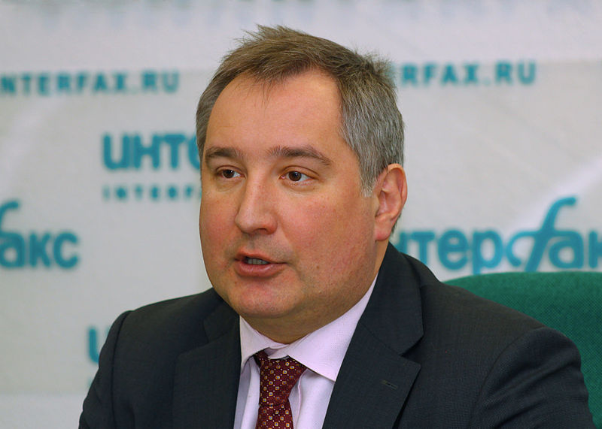 | Dmitry Rogozin  Vice-premier of the Russian Government
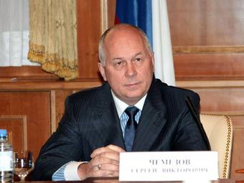 | Sergei Chemezov  Chairman of the «Russian Mechanical Engineering Union»,  Director General of State Corporation “Russian Technologies”
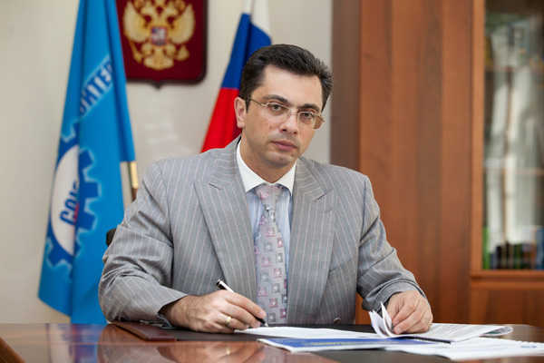 | Vladimir Gutenev  First Deputy Chairman of the «Russian Mechanical Engineering Union»,  First Deputy Chairman of the State Duma Committee on industry of the Russian Federation  Chairman of the Association "League for the advancement to defense enterprises""
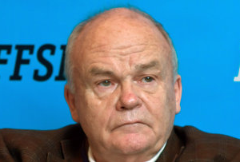 | Evgeny Velikhov  President of the Kurchatov Institute,  First Secretary of the Public Chamber of the Russian Federation  Chairman of the ITER Council
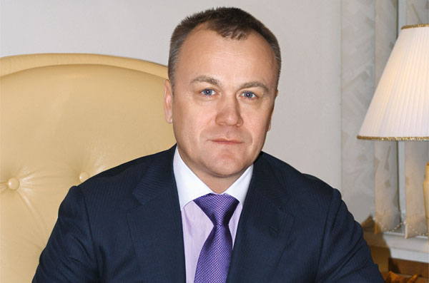 | Sergei Eroshchenko  Governor of Irkutsk Region
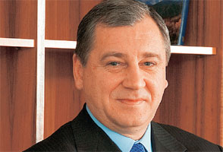 | Boris Alyoshin  General Director of the Central Aerohydrodynamic Institute (TsAGI)
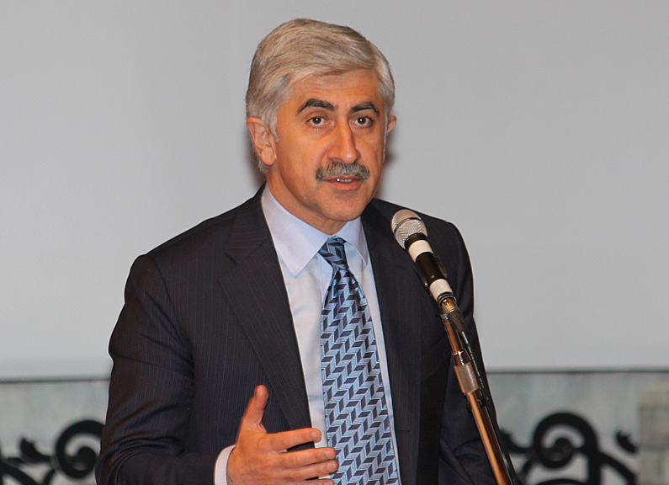 | Mikhail Pogosyan  General Director of the JSC “Sukhoi Design Bureau”
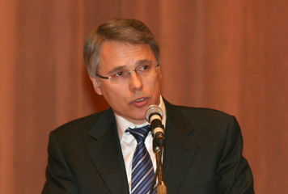 | Anatoliy Alexandrov  Rector of the Bauman Moscow State Technical University (Bauman MSTU)
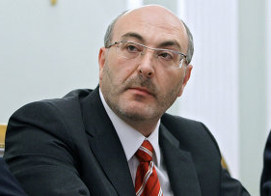 | Michail Bolotin  President, Chief Executive Officer of Corporate Management “Concern “ Tractor plants”
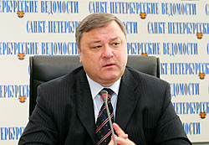 | Valentin Gapanovich  Senior Vice-President of JSC "Russian Railways"
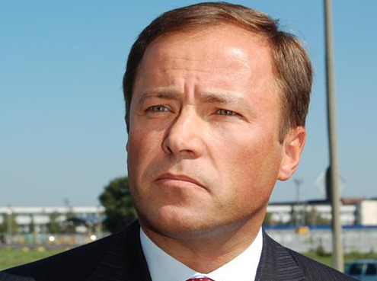 | Igor Komarov  President of JSC “AvtoVAZ”
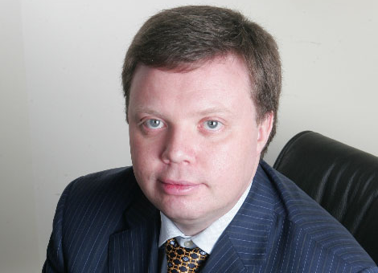 | Kirill Komarov  Deputy Director General for Development and International Business SC "Rosatom"
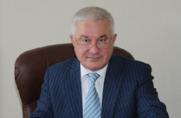 | Azret Beckiev  General Director of JSC “Concern “Sozvezdie”  Vice-President of the Association "League for the advancement to defense enterprises"
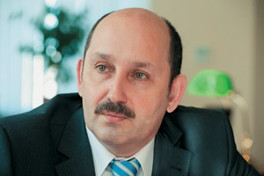 | Sergei Grigoriev  Rector of the Moscow State Technological University “Stankin”
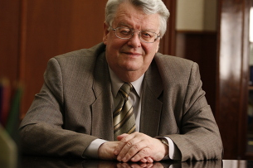 | Igor Fedorov  President the Bauman Moscow State Technical University
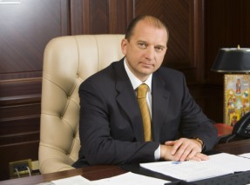 | Vladimir Artyakov  Deputy Director General of the State Corporation “Russian Technologies”
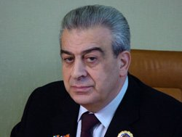 | Givi Janjgava  President, General Designer of JSC "Ramenskoye Design Company"
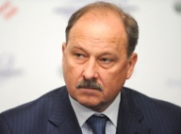 | Vladimir Dmitriev  Chairman of the Group of Companies "Vnesheconombank"
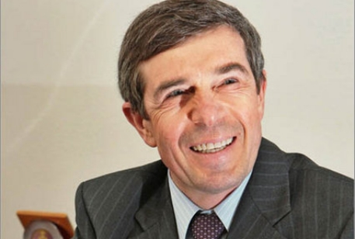 | Anatoly Isaikin  General Director of “Rosoboronexport”
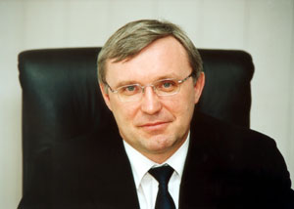 | Sergey Kogogin  General Director of JSC "KAMAZ"
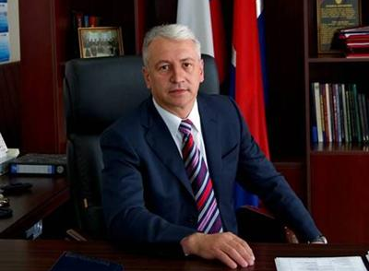
  Nikolai Kolesov
  General Director of the Concern “Radioelectronic Technologies”
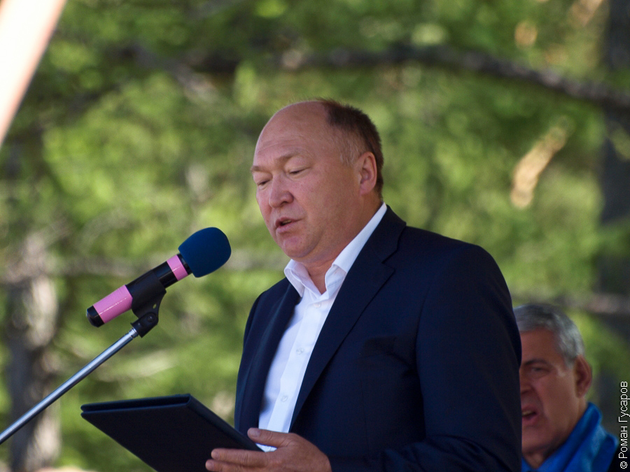 | Alexei Fedorov  Vice President of the “Russian Mechanical Engineering Union”  Advisor to General Director of “Russian Technologies"
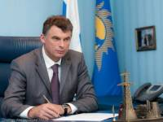 | Nikolai Shvets  Vice President of the “Russian Mechanical Engineering Union”  General Director of Interregional Distribution Grid Companies
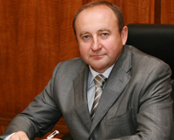 | Vladimir Zarudny  Director General of the "Elektrostal Heavy Engineering works"
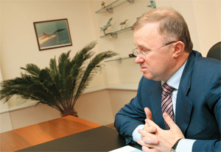 | Sergei Maxin  General Director of JSC “SPC” Optical Systems and Technologies”
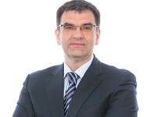
  Sergei Nedoroslev
  Chairman of the Court of Directors of the “Management Company “Kaskol”
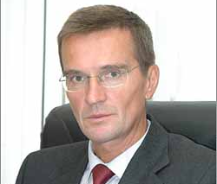 | Boris Obnosov  General Director of JSC "Corporation “Tactical missile munitions”
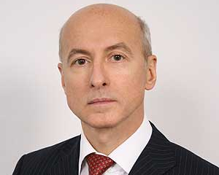 | Alexander Rybas  General Director of "Prominvest"
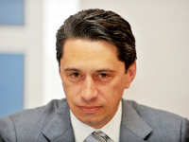 | Oleg Sienko  General Director of JSC "SPC" UralVagonZavod "Dzerzhinsky"
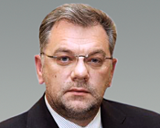 | Dmitrii Shugaev  Deputy General Director of the State Corporation “Russian Technologies”

